News Release

AirSept Will Exhibit Time-Saving Line Repair Tools
As First Time Exhibitor at 2019 VISION Hi-Tech Training & Expo

Company will unveil its technician-friendly Pro Series Smart Splice line repair kits along
with a show giveaway, drawing and discount promotions

Atlanta – Feb. 25, 2019 – AirSept will exhibit its aftermarket solutions for complex automotive repair problems at the 2019 VISION Hi-Tech Training & Expo in Kansas City at booth (#808) during the exhibit-only portion of the show, March 1-2. In addition, the company will unveil its new Smart Splice™ Pro Series kits, along with a show giveaway, drawing and promotion.

AirSept’s Smart Splice™ Pro Series – Trans & P/S Kit (part # 78019) is the newest extension to the company’s popular line of products for quick, durable line repair. The new kit provides technicians everything needed to fix a damaged metal line or connect a metal line to a hose for transmission and power steering service. Repairs can be completed in five minutes, with no line removal needed.

The first 300 technicians who visit the AirSept VISION booth (#808) will receive a free, certified leak-free 3/8” Smart Splice line-to-hose connector. AirSept will also offer attendees the opportunity to sign up for the company’s show giveaway. One lucky recipient will receive a Smart Splice™ Pro Series – Trans & P/S kit. The drawing will be held March 15, 2019.

“Automotive technicians appreciate our time and money-saving tools designed to help them do their jobs faster and easier,” said AirSept president Aaron Becker. “We look forward to being at the VISION Expo and the opportunity to interact with front line technicians and shop owners who daily face a variety of automotive repair challenges.”

Becker says the company is offering a special VISION show-only promotion. Attendees who order any of the company’s Smart Splice Line Repair Kits during the show will receive a 25 percent discount. In addition, AirSept’s new Smart Splice™ Pro Series – Trans & P/S kit is available at a special, March-only 20 percent off product introduction discount.

VISION Hi-Tech Training & Expo provides attendees with the opportunity to learn and network with leading shop owners, managers and technicians. In 2018, VISION hosted over 3,500 attendees from 44 U.S. states, 7 Canadian provinces, the British Virgin Islands, Puerto Rico, Guatemala and Zimbabwe. Choose from cutting-edge management and technical training courses, including live-car and hands-on training. VISION also features a 60,000 square-foot exhibit hall showcasing the latest tools, equipment and technology. For more information, visit www.visionkc.com.

For more information on AirSept’s award-winning line of products that solve challenging automotive repair problems, visit www.AirSept.com.

# # # #
Image Attached: 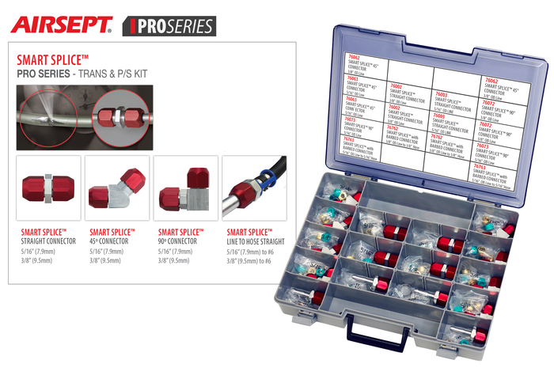

About AirSept
In 1989 AirSept created the first long-lasting solution to the problem of unwanted mold and mildew odor in automobile air conditioning systems. The product quickly became popular and in 1991 AirSept was incorporated as a company. AirSept began partnering with global OEMs and suppliers to not only market its Cooling Coil Coating, but to also develop other unique, new problem-solving products. From those humble beginnings, AirSept has grown to be the industry leader in the development of OEM and aftermarket solutions to complex automotive repair problems. AirSept products are designed to save time, money and labor. For more information, visit www.AirSept.com.

For further product information, contact:
Aaron Becker, President
AirSept
678-973-2287
abecker@airsept.com

For further PR information, contact:
Gary McCoy, President
Fairway Communications
847-372-0722
gmccoy@fairwaycommunications.com

Leslie Allen
Owner
Wildcat Communications
615-429-7965
leslieallen.wildcat@gmail.com

